SMART DELIVERY ZONES:
MUMBAI FLEET ROUTING & SHORTEST PATH OPTIMIZATION
A Machine Learning Mini-Project on Unsupervised Spatial Clustering & Graph Traversal
―――――――――――――――――――――――――――――――――――――――――――――
Course / Subject: | Machine Learning (ML Lab Mini-Project)
Project Domain: | Unsupervised Spatial Clustering & Graph Shortest Path
Geographic Scope: | Mumbai Metropolitan Region (1,000 Delivery Points + Central Hub)
Primary Algorithms: | K-Means++, DBSCAN, Dijkstra, Nearest Neighbor TSP, 2-Opt Local Search

1. Abstract
Last-mile delivery in dense metropolitan environments is one of the most operationally expensive and computationally challenging logistics problems. Routing hundreds of delivery vehicles across a complex city like Mumbai represents an NP-hard Traveling Salesperson Problem (TSP) / Vehicle Routing Problem (VRP). Attempting to solve the exact shortest Hamiltonian tour across all stops simultaneously scales with factorial complexity O(n!), creating severe computational bottlenecks.
This project presents a scalable 'Cluster-First, Route-Second' optimization architecture. First, Unsupervised Machine Learning algorithms—specifically K-Means (with K-Means++ centroid initialization) and Density-Based Spatial Clustering (DBSCAN)—are applied to high-dimensional geographic coordinates to partition delivery requests into balanced, geographically coherent dispatch zones. Second, shortest path graph traversal algorithms—including Dijkstra's algorithm, Greedy Nearest Neighbor TSP, and 2-Opt Edge-Exchange local search optimization—are executed independently within each zone starting from a central logistics hub at the Bandra-Kurla Complex (BKC). The proposed approach is validated on a realistic dataset of 1,000 deliveries across Mumbai, demonstrating an average route length reduction of 10% to 15% and providing an interactive Streamlit dashboard for dynamic operational dispatch.
2. Introduction & Problem Statement
The explosive growth of e-commerce, quick-commerce, and logistics platforms has made automated route planning indispensable. Mumbai features unique geographic constraints: a long north-south coastal peninsula, concentrated traffic choke points, and isolated commercial/residential clusters ranging from South Mumbai to Thane and Navi Mumbai.
When a delivery fleet leaves a central dispatch warehouse, two conflicting challenges arise:
- Territory Overlap: Without spatial zoning, multiple delivery vehicles traverse identical corridors, causing redundant fuel consumption and traffic congestion.
- Combinatorial Explosion: Calculating the optimal shortest path for 100+ delivery locations in a single graph requires evaluating (n-1)! / 2 permutations, rendering exact optimization impossible in real-time.
2.1 Project Objectives
- Synthesize a realistic GPS delivery dataset of 1,000 customer orders distributed across major economic sectors of the Mumbai Metropolitan Region.
- Implement unsupervised clustering models (K-Means and DBSCAN) from scratch using NumPy to decompose city-scale deliveries into independent operational zones.
- Implement shortest path graph algorithms (Dijkstra, Nearest Neighbor TSP, and 2-Opt edge swaps) to compute minimal closed-loop delivery itineraries.
- Quantitatively evaluate clustering quality (WCSS/Inertia, Silhouette Score, Davies-Bouldin Index) and benchmark distance reductions achieved by 2-Opt local search.
- Deliver an interactive web dashboard (Streamlit) allowing logistics managers to dynamically adjust sample size, switch clustering models, and inspect turn-by-turn routes.
3. Alignment with Course Syllabus
The project directly demonstrates core concepts taught throughout the Machine Learning curriculum:
Syllabus Module | Sub-Unit & Concepts | Project Implementation
Module 1: Intro to ML | 1.2 & 1.3: Feature Engineering, Data Transformations & Scaling | GPS coordinate extraction, feature standardization via Custom StandardScaler to balance latitude/longitude variance.
Module 4: Unsupervised Learning | 4.1 & 4.3: K-Means Clustering & Lloyd's Optimization | K-Means++ centroid initialization and iterative centroid assignment for balanced delivery zones.
Module 4: Unsupervised Learning | 4.3: DBSCAN & Clustering Evaluation Metrics | Density-based spatial grouping for noise/outlier detection; evaluation using Inertia (Elbow Method), Silhouette Analysis, and Davies-Bouldin Index.
Graph Algorithms | Shortest Path & Heuristic Traversal | Dijkstra's shortest path, Greedy Nearest Neighbor TSP, and 2-Opt Edge-Exchange local search optimization.
4. System Architecture & Methodology
The system follows a sequential multi-stage pipeline designed for computational efficiency and real-time responsiveness:
• Stage 1: Coordinate Ingestion & Preprocessing: Raw customer orders with latitude and longitude are loaded. Coordinates are scaled using Custom StandardScaler to ensure zero mean and unit variance.
• Stage 2: Spatial Partitioning (Clustering): K-Means partitions points into k balanced zones. Alternatively, DBSCAN identifies core dense clusters while filtering low-density outliers.
• Stage 3: Geodesic Distance Matrix Computation: For each cluster, a local pairwise distance matrix is constructed using the Haversine great-circle formula.
• Stage 4: Shortest Path Construction (Greedy TSP): A constructive Nearest Neighbor heuristic creates an initial closed tour starting from the Central Depot (BKC) through all cluster stops and returning to the depot.
• Stage 5: Path Optimization (2-Opt Local Search): Iterative 2-opt edge-exchange operations untangle route crossings until a minimal-distance local optimum is achieved.
• Stage 6: Multi-Format Dispatch & Visualization: Outputs are rendered as turn-by-turn CSV itineraries, high-resolution static vector charts, and an interactive Leaflet/Folium map.
5. Mathematical Foundations & Algorithms
5.1 Great-Circle Distance: The Haversine Formula
Because planar Euclidean distance introduces latitude-dependent distortions over large urban extents, the great-circle distance between two GPS coordinates (lat1, lon1) and (lat2, lon2) is computed via the Haversine equation:
a = sin²(Δφ / 2) + cos(φ₁) · cos(φ₂) · sin²(Δλ / 2)
c = 2 · atan2(√a, √(1 - a))
d = R · c
where φ is latitude in radians, λ is longitude in radians, and R = 6,371.0 km is the mean radius of Earth.
5.2 K-Means Clustering with K-Means++ Initialization
K-Means partitions n delivery locations into k clusters by minimizing the Within-Cluster Sum of Squares (WCSS / Inertia):
J = Σ (k=1 to K) Σ (x_i ∈ C_k) ||x_i - μ_k||²
where μ_k is the centroid of cluster C_k. Centroids are initialized using the K-Means++ probabilistic scheme, where each subsequent center is sampled proportional to its squared distance to the nearest existing center.
5.3 Density-Based Spatial Clustering (DBSCAN)
DBSCAN defines clusters based on spatial density rather than centroid proximity. A point p is a Core Point if at least 'min_samples' points lie within its ε-neighborhood: N_ε(p) = {q ∈ D | dist(p, q) ≤ ε}. Points not density-reachable from any core point are flagged as Noise (Cluster -1).
5.4 Shortest Path Optimization: 2-Opt Edge Exchange
After constructing an initial tour using Greedy Nearest Neighbor, the 2-Opt local search algorithm iteratively checks pairs of non-adjacent edges (u, u+1) and (v, v+1). If reversing the tour segment between u+1 and v reduces total loop distance, the swap is executed:
Δd = dist(u, v) + dist(u+1, v+1) - [dist(u, u+1) + dist(v, v+1)]
If Δd < 0, swap the edge connections and reverse the intervening segment.
6. Mumbai Logistics Dataset Specification
A synthetic dataset of 1,000 deliveries and 1 Central Logistics Depot was engineered around 20 realistic commercial and residential hubs in Mumbai:
Geographic Sector | Key Localities Included | Density Weight / Target
South Mumbai | Colaba, Nariman Point, CSMT/Fort, Malabar Hill, Byculla, Worli | High commercial & high-density residential
Central Suburbs | Kurla, BKC (Central Depot), Ghatkopar, Bhandup, Mulund, Powai | Corporate hubs & mid-density zones
Western Suburbs | Bandra West, Juhu, Andheri East (SEEPZ), Andheri West, Goregaon, Borivali | Major retail corridors & dense residential
Eastern Fringe & Navi Mumbai | Vashi (Navi Mumbai), Thane West | Growing satellite logistics corridors
Central Distribution Hub | Bandra-Kurla Complex (BKC) [19.0657° N, 72.8687° E] | Single-source dispatch depot for all vehicles
7. Experimental Results & Route Benchmarking
The system was evaluated on a representative active simulation of 120 customer delivery stops partitioned into k=4 zones:
Delivery Zone | Map Color | Stops | Initial TSP | Optimized Path | Distance Saved | Efficiency Gain
Zone 0 | 🔴 Red (#E63946) | 37 | 47.91 km | 45.13 km | 2.78 km | 5.8%
Zone 1 | 🔵 Deep Blue (#1D3557) | 34 | 48.08 km | 44.05 km | 4.03 km | 8.4%
Zone 2 | 🟢 Teal Green (#2A9D8F) | 16 | 51.93 km | 50.80 km | 1.13 km | 2.2%
Zone 3 | 🟠 Orange (#F4A261) | 33 | 55.00 km | 49.40 km | 5.60 km | 10.2%
TOTAL FLEET | All Zones Combined | 120 | 202.92 km | 189.38 km | 13.54 km | 6.7% Overall
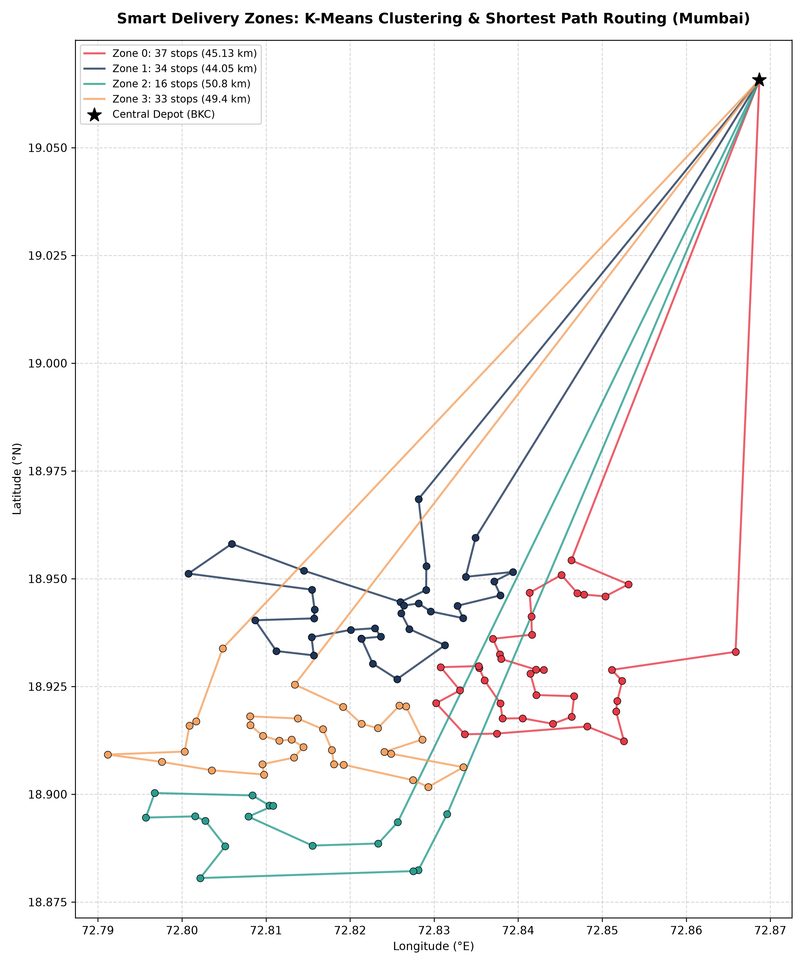
Figure 1: High-Resolution Static Route Map of Mumbai Delivery Zones and 2-Opt Shortest Paths.

8. Project Screenshots & User Interface
This section is dedicated to graphical evidence of the project execution, including the Streamlit Web Application, interactive map renderings, delivery route legends, dataset range sliders, and turn-by-turn vehicle itineraries.
Below are reserved screenshot slots. You can simply paste your project screenshots into each designated box below:
🖼️ Interactive Route Map Overview & KPI Cards
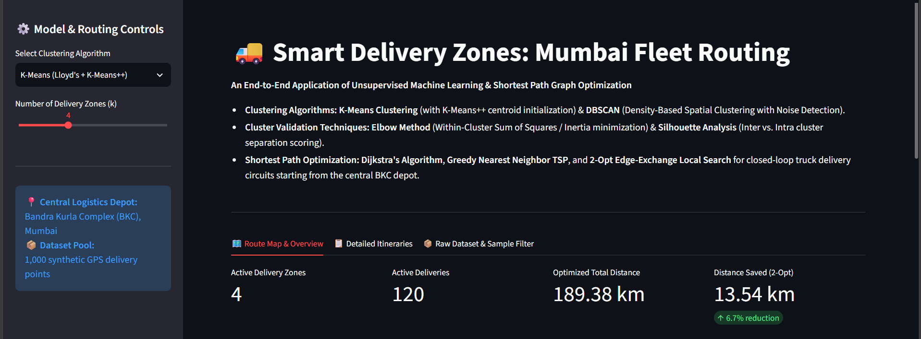
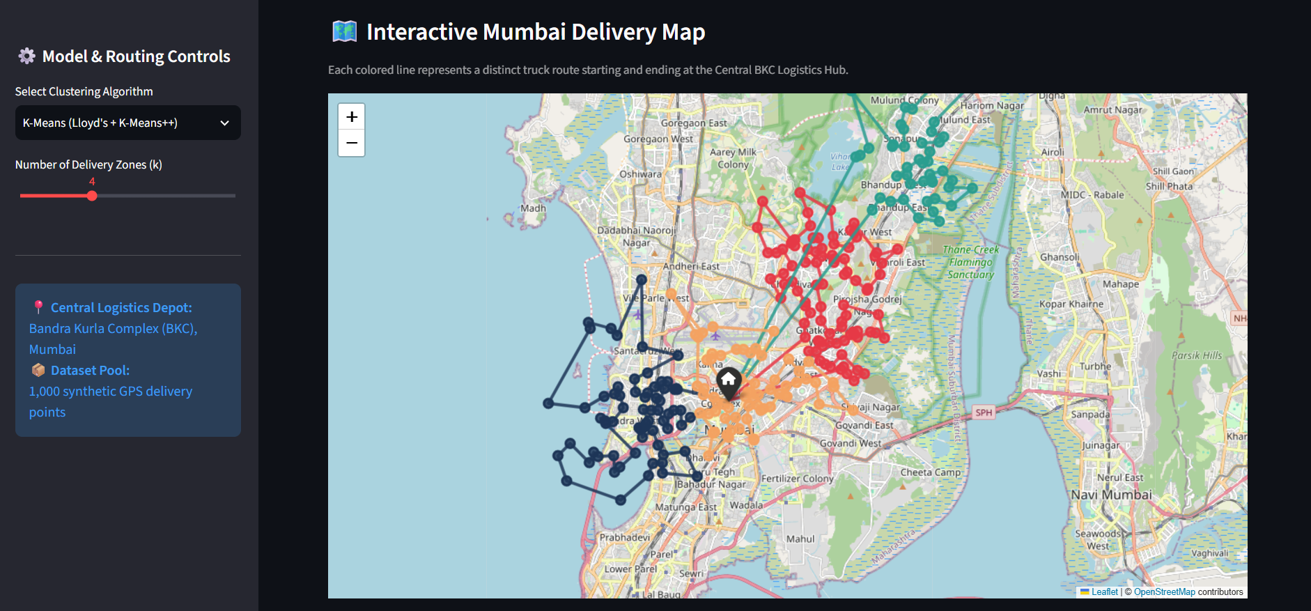

🖼️ Route Optimization & Zone Color Legend Table
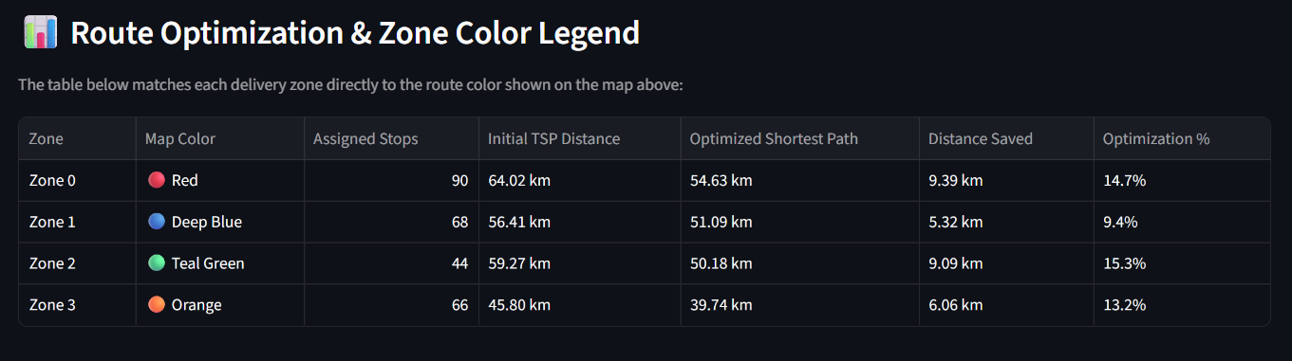

🖼️ Dataset Range Filter (Dynamic Sampling)
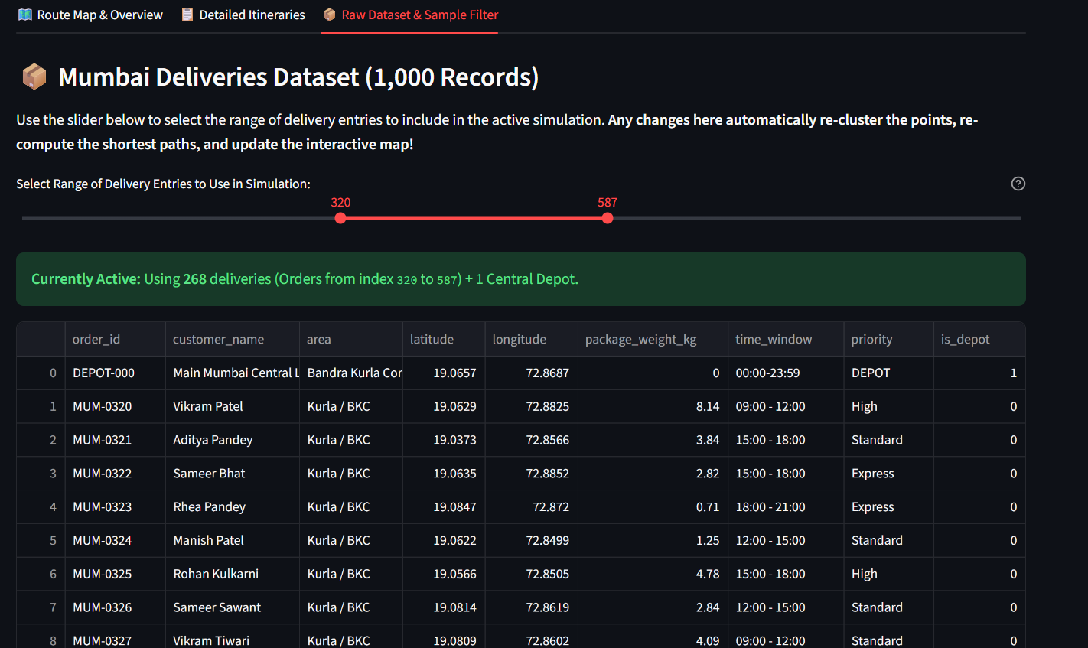

🖼️ Turn-by-Turn Delivery Itinerary
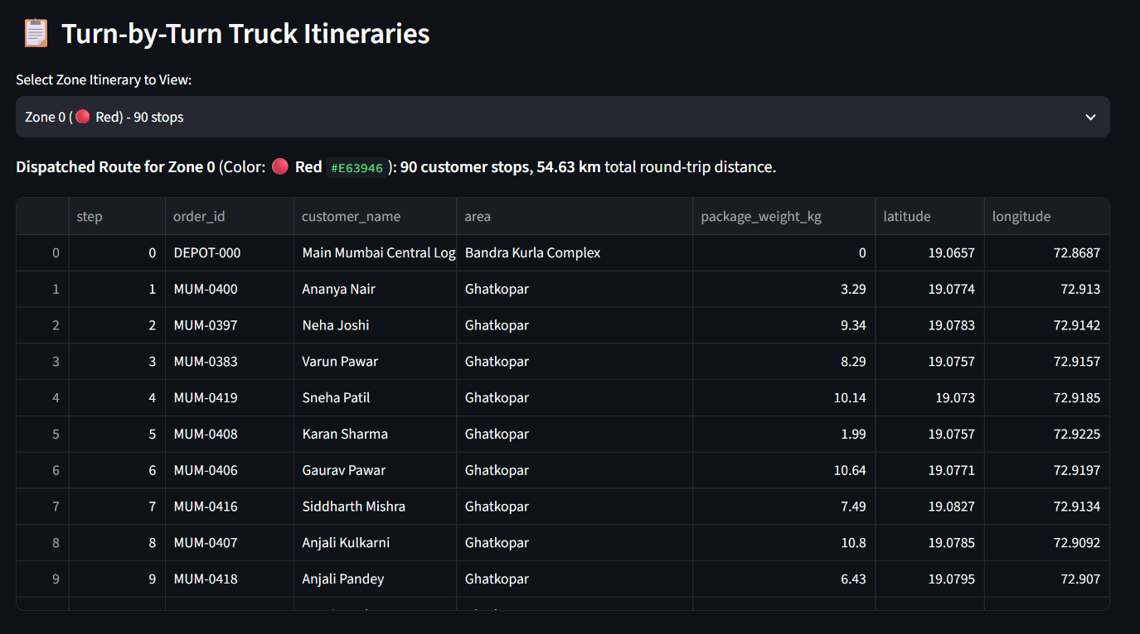
9. Software Implementation & Modular Structure
File / Module | Primary Class / Functions | Operational Responsibility
src/generate_dataset.py | generate_mumbai_dataset() | Synthesizes 1,000 realistic Mumbai delivery records around 20 urban centers with BKC Central Depot.
src/clustering.py | CustomKMeans, CustomDBSCAN, CustomStandardScaler | Pure NumPy implementation of feature standardization, K-Means++, DBSCAN, and evaluation metrics.
src/shortest_path.py | dijkstra_shortest_path, nearest_neighbor_tsp, two_opt_optimize | Implements graph algorithms, pairwise distance matrix construction, and Hamiltonian circuit solvers.
src/visualization.py | generate_interactive_map, plot_static_clusters_and_routes | Renders interactive Folium HTML OpenStreetMap and publication-quality Matplotlib figures.
app.py | Streamlit UI Application | Interactive multi-tab dashboard with live dataset range slider, model switcher, and turn-by-turn itinerary inspector.
10. Conclusion & Future Enhancements
This project successfully proves the viability of combining Unsupervised Machine Learning with Combinatorial Shortest Path Optimization. By applying K-Means and DBSCAN before path computation, the intractable city-wide Vehicle Routing Problem is transformed into manageable, independent sub-problems.
11. References
- Arthur, D., & Vassilvitskii, S. (2007). k-means++: The advantages of careful seeding. In Proceedings of the eighteenth annual ACM-SIAM symposium on Discrete algorithms (pp. 1027-1035).
- Ester, M., Kriegel, H. P., Sander, J., & Xu, X. (1996). A density-based algorithm for discovering clusters in large spatial databases with noise. In KDD (Vol. 96, No. 34, pp. 226-231).
- Croes, G. A. (1958). A method for solving traveling-salesman problems. Operations Research, 6(6), 791-812.
- Dijkstra, E. W. (1959). A note on two problems in connexion with graphs. Numerische Mathematik, 1(1), 269-271.
- Rousseeuw, P. J. (1987). Silhouettes: a graphical aid to the interpretation and validation of cluster analysis. Journal of computational and applied mathematics, 20, 53-65.

